# 编译步骤

## 版本

Jdk8



## 步骤

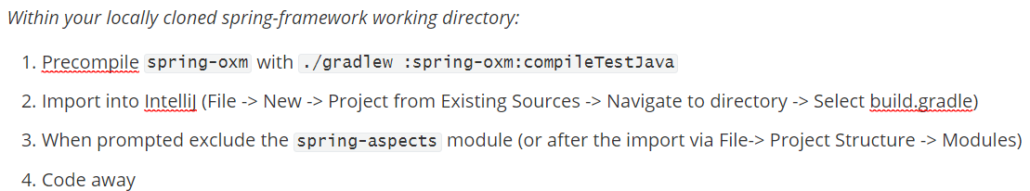

地址：spring-framework-5.2.6.RELEASE**\**import-into-idea.md

# 阿里云仓库

仓库官网

<https://developer.aliyun.com/mvn/guide>

build.gradle

#插件地址

maven { url "https://maven.aliyun.com/repository/spring-plugin" }

maven { url "https://maven.aliyun.com/repository/gradle-plugin" }

#仓库地址

maven { url "https://maven.aliyun.com/repository/spring" }

maven { url "https://maven.aliyun.com/repository/central" }

maven { url "https://maven.aliyun.com/repository/public" }

# Spring-5.2.6编译

## 1.修改build.gradle

地址：spring-framework-5.2.6.RELEASE**\**build.gradle

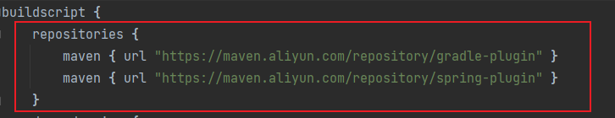

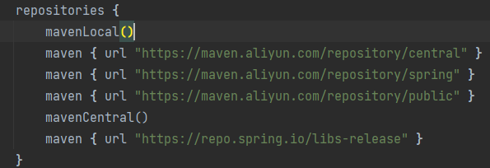



## 2.gradle-wrapper.properties

地址：spring-framework-5.2.6.RELEASE \gradle\wrapper

**distributionUrl=file:///D:/myprogram/gradle-4.4.1-bin.zip**



## 3.编译命令

**gradlew :spring-oxm:compileTestJava**

# Idea配置

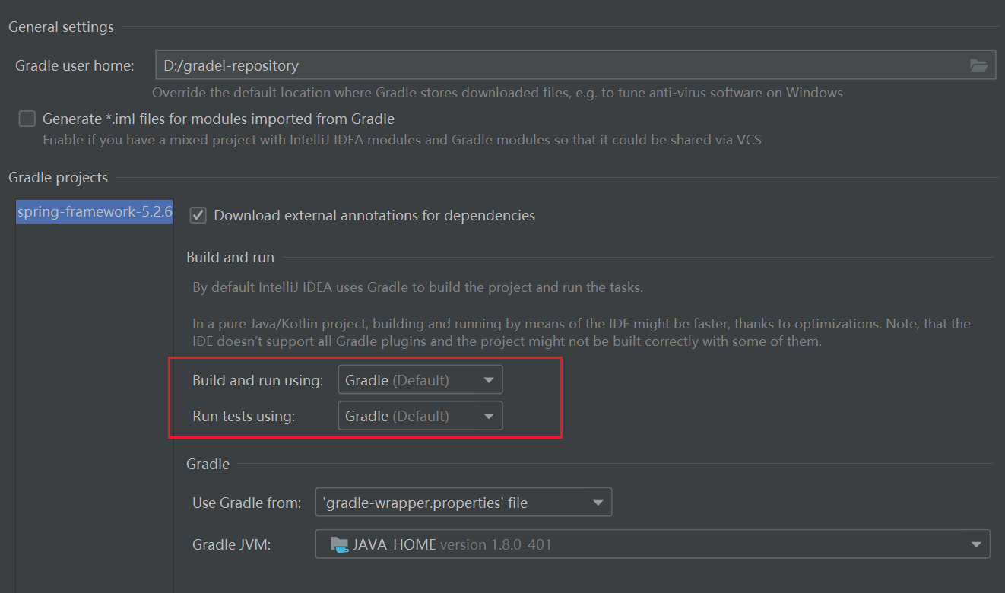

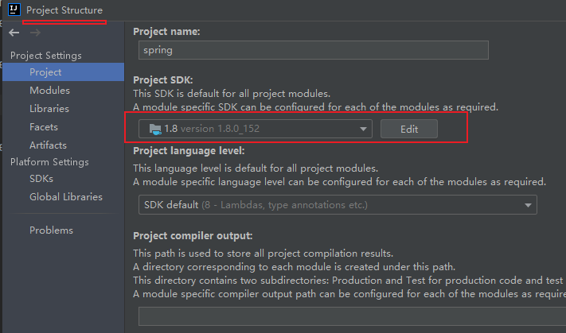

# 编译测试

先编译spring-oxm, spring-core,spring-context

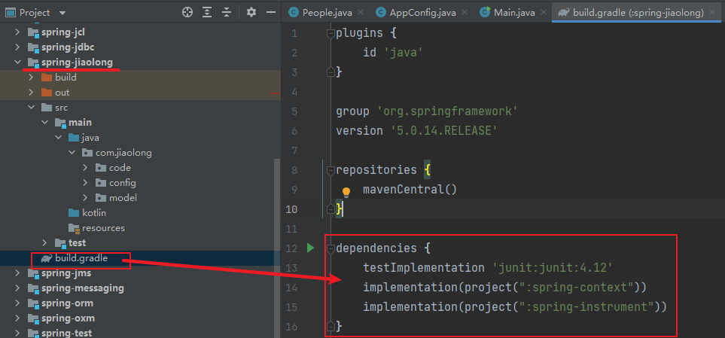 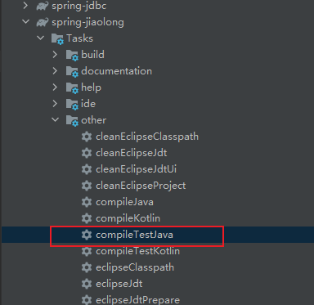

dependencies {

testImplementation 'junit:junit:4.12'

implementation(project(":spring-context"))

implementation(project(":spring-instrument"))

}



# 参考文章

1.Spring源码下载&构建<https://www.zhihu.com/question/400486014>